System Design Specification
For
Microfinance Loan + EMI Tracking – Loan Servicing Control

Date:
Prepared By:
- Introduction
1.1 Purpose
The purpose of this document is to present a detailed description of the Microfinance Loan + EMI Tracking – Loan Servicing Control System. It explains the objectives, major functionalities, and overall working of the system. This document is intended for Admin, Manager, and User, as well as developers who are involved in designing, implementing, and maintaining the system.
1.2 Scope of Project
The scope of the Microfinance Loan + EMI Tracking System is to provide a structured and efficient platform for managing microfinance loan operations. The system enables maintenance of customer records, loan details, EMI schedules, and repayment information. It supports role-based access for Admin, Manager, and User to ensure secure data handling and controlled operations. The system also assists in tracking overdue EMIs, outstanding loan amounts, and repayment history to improve financial monitoring and loan servicing efficiency.
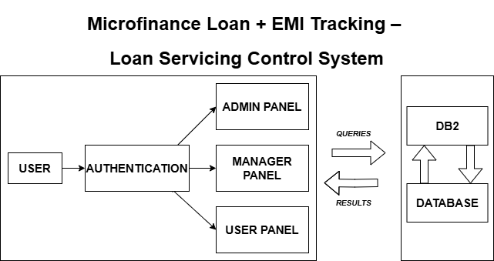
- System Overview
2.1 Architecture
The Microfinance Loan + EMI Tracking – Loan Servicing Control System is a centralized application designed to automate and manage microfinance loan activities. It handles customer information, loan creation, EMI calculation, and repayment tracking. The system minimizes manual work, improves data accuracy, and provides quick access to loan and EMI status. Admin manages system configuration, Manager monitors loan performance, and Users handle day-to-day loan and EMI entries, ensuring smooth and reliable loan servicing.

2.2 Flow Chart
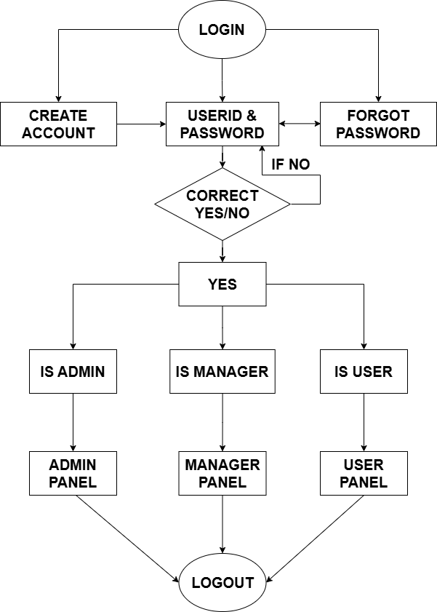

- Development Tools
This section is an account of technologies that could be used in development of the system.

3.1 Front End Technology

- RPG

RPG syntax in free form is like other modern languages and can be understood easily. It allows programmers who are familiar with other languages such as Microsoft Visual Basic, Java, and PHP to be trained more easily in RPG and with lower cost. The new syntax also makes programming easier for existing RPG programmers. As such, the free-form syntax is beneficial for both existing RPG programmers and new RPG programmers.
Free-form RPG allows code to be specified as free-form statements rather than in specific fixed columns.

Free-form code is still restricted to columns 8 – 80.

The /FREE and /END-FREE compiler directives are tolerated but are no longer required for free-form.

3.2 Backend Technology

- DB2

The language that you use to access the data in Db2 tables is the structured query language (SQL). SQL is a standardized language for defining and manipulating data in a relational database.
The language consists of SQL statements. You can issue SQL statements to accomplish the following actions:
  - Define, modify, or drop data objects, such as tables.
  - Retrieve, insert, update, or delete data in tables.

3.3 ER Diagram

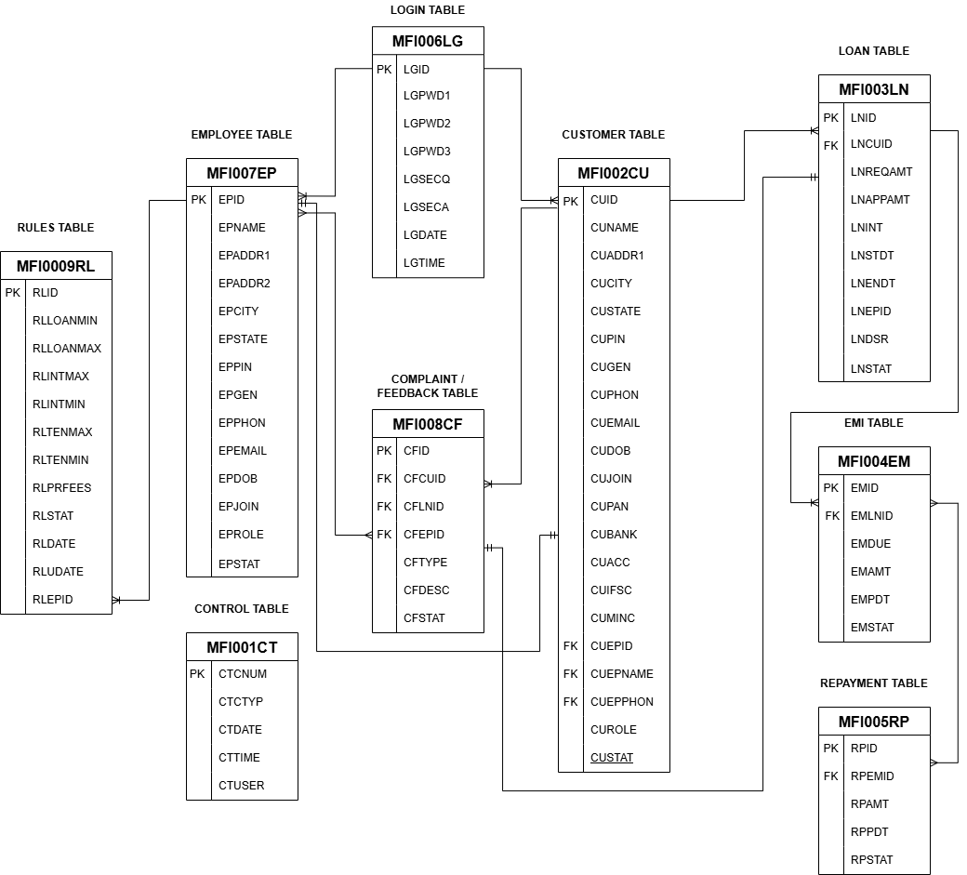

4: Data Directory
A data dictionary is a collection of descriptions of data objects or items in a data model for the benefit of programmers and others who need to refer to them. The dictionary gives a brief description of the objects that will be needed to form the online employee management system.

PF Structure:

4.1. MFI001CT (Format MFI001CT) – Control Table

PF Name | Record Format | Field Name | Description | Type | Length | Validations
MFI001CT | MFI001CT | CTCTYP | Control Type | A | 1 | C/L/E/R
MFI001CT | MFI001CT | CTCNUM | Control Number | N | 6,0 | System Generated
MFI001CT | MFI001CT | CFDATE | Add/Update Date | D
MFI001CT | MFI001CT | CFTIME | Add/Update Time | N | 6,0
MFI001CT | MFI001CT | CFUSER | Add/Update User | A | 10

4.2. MFI002CU (Format MFI002CU) – Customer Table

PF Name | Record Format | Field Name | Description | Type | Length | Validations
MFI002CU | MFI002CU | CUID | Customer ID | A | 6 | Auto C
MFI002CU | MFI002CU | CUNAME | Customer Name | A | 30 | Mandatory
MFI002CU | MFI002CU | CUADDR1 | Address Line 1 | A | 40
MFI002CU | MFI002CU | CUADDR2 | Address Line 2 | A | 40
MFI002CU | MFI002CU | CUCITY | City | A | 20
MFI002CU | MFI002CU | CUSTATE | State | A | 20
MFI002CU | MFI002CU | CUPIN | PIN Code | N | 6,0 | Numeric
MFI002CU | MFI002CU | CUGEN | Gender | A | 1 | Mandatory
MFI002CU | MFI002CU | CUPHON | Phone No. | A | 10 | Numeric
MFI002CU | MFI002CU | CUEMAIL | Email | A | 40 | Email Format
MFI002CU | MFI002CU | CUDOB | Date of Birth | D |  | <=Today & 18 Years or above
MFI002CU | MFI002CU | CUJOIN | Join Date | D |  | <=Today
MFI002CU | MFI002CU | CUPAN | PAN Number | A | 10 | AAAAANNNNA
MFI002CU | MFI002CU | CUBANK | Bank Name | A | 30
MFI002CU | MFI002CU | CUACC | Bank Account No. | A | 20 | Numeric
MFI002CU | MFI002CU | CUIFSC | IFSC Code | A | 11 | IFSC Format
MFI002CU | MFI002CU | CUMINC | Monthly Income | N | 10,2 | >=0
MFI002CU | MFI002CU | CUEPID | Assigned Manager ID | A | 6 | Exists in MFI007EP (EPID)
MFI002CU | MFI002CU | CUEPNAME | Assigned Manager Name | A | 30 | Exists in MFI007EP (EPNAME)
MFI002CU | MFI002CU | CUEPPHON | Assigned Manager Phone | A | 10 | Exists in MFI007EP (EPPHON)
MFI002CU | MFI002CU | CUROLE | Role | A | 1 | C
MFI002CU | MFI002CU | CUSTAT | Status | A | 1 | A/I

4.3. MFI003LN (Format MFI003LN) – Loan Table

PF Name | Record Format | Field Name | Description | Type | Length | Validations
MFI003LN | MFI003LN | LNID | Loan ID | A | 6 | Auto L
MFI003LN | MFI003LN | LNCUID | Customer ID | A | 6 | Exists in MFI002CU (CUID)
MFI003LN | MFI003LN | LNREQAMT | Requested Amount | N | 10,2 | >=0
MFI003LN | MFI003LN | LNAPPAMT | Approved Amount | N | 10,2 | >=0
MFI003LN | MFI003LN | LNINT | Interest Rate | N | 5,2 | 0-100
MFI003LN | MFI003LN | LNSTDT | Start Date | D |  | Mandatory
MFI003LN | MFI003LN | LNENDT | End Date | D |  | >= Start Date
MFI003LN | MFI003LN | LNEPID | Approved By Manger ID | A | 6 | Exists in MFI007EP (EPID)
MFI003LN | MFI003LN | LNDSR | DSR % | N | 5,2 | System Calculated
MFI003LN | MFI003LN | LNSTAT | Status | A | 1 | P/A/R/C

4.4. MFI004EM (Format MFI004EM) - EMI Table

PF Name | Record Format | Field Name | Description | Type | Length | Validations
MFI004EM | MFI004EM | EMID | EMI ID | A | 6 | Auto E
MFI004EM | MFI004EM | EMLNID | Loan ID | A | 6 | Exists in MFI003LN (LNID)
MFI004EM | MFI004EM | EMDUE | Due Date | D |  | Mandatory
MFI004EM | MFI004EM | EMAMT | Amount | N | 10,2 | >=0
MFI004EM | MFI004EM | EMPDDT | Paid Date | D |  | Optional
MFI004EM | MFI004EM | EMSTAT | Status | A | 1 | P/U

4.5. MFI005RP (Format MFI005RP) - Repayment Table

PF Name | Record Format | Field Name | Description | Type | Length | Validations
MFI005RP | MFI005RP | RPID | Repayment ID | A | 6 | Auto R
MFI005RP | MFI005RP | RPEMID | EMI ID | A | 6 | Exists in MFI004EM (EMID)
MFI005RP | MFI005RP | RPAMT | Paid Amount | N | 10,2 | >=0
MFI005RP | MFI005RP | RPPDDT | Paid Date | D |  | Mandatory
MFI005RP | MFI005RP | RPSTAT | Status | A | 1 | P/H/S/F
4.6. MFI006LG (MFI006LG) – Login Table

PF Name | Record Format | Field Name | Description | Type | Length | Validations
MFI006LG | MFI006LG | LGID | Login ID | A | 6 | Exists in MFI002CU (CUID) OR  MFI007EP (EPID)
MFI006LG | MFI006LG | LGPWD1 | Password 1 | A | 10 | Mandatory
MFI006LG | MFI006LG | LGPWD2 | Password 2 | A | 10 | Optional
MFI006LG | MFI006LG | LGPWD3 | Password 3 | A | 10 | Optional
MFI006LG | MFI006LG | LGSECQ | Security Question | A | 50 | Mandatory
MFI006LG | MFI006LG | LGSECA | Security Answer | A | 50 | Mandatory
MFI006LG | MFI006LG | LGDATE | Login Date | D |  | Mandatory
MFI006LG | MFI006LG | LGDATE | Login Time | T |  | Mandatory

4.7. MFI007EP (MFI007EP) – Employee Table

PF Name | Record Format | Field Name | Description | Type | Length | Validations
MFI007EP | MFI007EP | EPID | Employee ID | A | 6 | Auto EP
MFI007EP | MFI007EP | EPNAME | Employee Name | A | 30 | Mandatory
MFI007EP | MFI007EP | EPADDR1 | Address Line 1 | A | 40
MFI007EP | MFI007EP | EPADDR2 | Address Line 2 | A | 40
MFI007EP | MFI007EP | EPCITY | City | A | 20
MFI007EP | MFI007EP | EPSTATE | State | A | 20
MFI007EP | MFI007EP | EPPIN | PIN Code | N | 6,0 | Numeric
MFI007EP | MFI007EP | EPGEN | Gender | A | 1 | Mandatory
MFI007EP | MFI007EP | EPPHON | Phone No. | A | 10 | Numeric
MFI007EP | MFI007EP | EPEMAIL | Email | A | 40 | Email Format
MFI007EP | MFI007EP | EPJOIN | Date of Birth | D |  | <= Today &  18 years or above
MFI007EP | MFI007EP | EPJOIN | Join Date | D |  | <= Today
MFI007EP | MFI007EP | EPROLE | Role | A | 1 | A/M
MFI007EP | MFI007EP | EPSTAT | Status | A | 1 | A/I

4.8. MFI008CF (MFI008CF) – Complaint/Feedback Table

PF Name | Record Format | Field Name | Description | Type | Length | Validations
MFI008CF | MFI008CF | CFTID | Ticket ID | A | 6 | Auto T
MFI008CF | MFI008CF | CFCUID | Customer ID | A | 6 | Exists in MFI002CU(CUID)
MFI008CF | MFI008CF | CFLNID | Loan ID | A | 6 | Exists in MFI003LN(LNID)
MFI008CF | MFI008CF | CFEPID | Assigned Manager ID | A | 6 | Exists in MFI007EP(EPID)
MFI008CF | MFI008CF | CFTYP | Type | A | 1 | C/F
MFI008CF | MFI008CF | CFDESC | Description | A | 100 | Mandatory
MFI008CF | MFI008CF | CFSTAT | Status | N | 1 | O/C

4.9. MFI009RL (MFI009RL) – Rules Table

PF Name | Record Format | Field Name | Description | Type | Length | Validations
MFI009RL | MFI009RL | RLID | Rule ID | A | 6 | Auto RL
MFI009RL | MFI009RL | RLLOANMIN | Minimum Loan Amount | N | 10,2 | >=0
MFI009RL | MFI009RL | RLLOANMAX | Maximum Loan Amount | N | 10,2 | >= RLLOANMIN
MFI009RL | MFI009RL | RLINTMIN | Minimum Interest Rate (%) | N | 5,2 | 0-100
MFI009RL | MFI009RL | RLINTMAX | Maximum Interest Rate (%) | N | 5,2 | >= RLINTMIN
MFI009RL | MFI009RL | RLTENMIN | Minimum Tenure (Months) | N | 3,0 | >0
MFI009RL | MFI009RL | RLTENMAX | Maximum Tenure (Months) | N | 3,0 | >= RLTENMIN
MFI009RL | MFI009RL | RLPRFEES | Processing Fees | N | 5,2 | >=0
MFI009RL | MFI009RL | RLSTAT | Status | A | 1 | A/I
MFI009RL | MFI009RL | RLDATE | Created Date | D
MFI009RL | MFI009RL | RLUDATE | Updated Date | D
MFI009RL | MFI009RL | RLEPID | Admin User Id | A | 6 | Exists MFI007EP(EPID)

LF Structure:

LF Name | Record Format | Based On PF | Keys / Sort Order
MFIL0011 | MFI001CF | MFI001CT | Control Type
MFIL0021 | MFI002CU | MFI002CU | Customer ID (Ascending)
MFIL0022 | MFI002CU | MFI002CU | Customer Name (Ascending)
MFIL0031 | MFI003LN | MFI005LN | Loan ID (Ascending)
MFIL0032 | MFI003LN | MFI005LN | Customer ID, Status (A/C)
MFIL0041 | MFI004EM | MFI006EM | Loan ID, Due Date (Ascending)
MFIL0042 | MFI004EM | MFI006EM | Status (P/U)
MFIL0051 | MFI005RP | MFI007RP | EMI ID, Status (S/F)

5: Data Flow Diagram
5.1. ADMIN
Level – 1
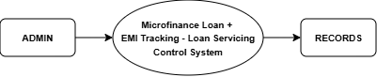
Level – 2
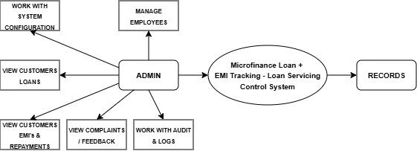
Level – 3
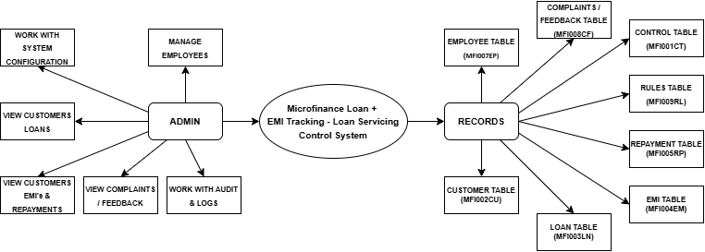

5.2. MANAGER
Level – 1

Level – 2
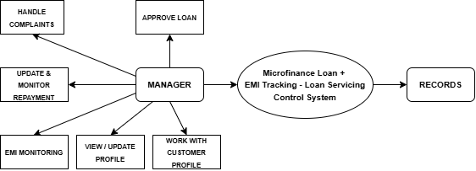
Level – 3
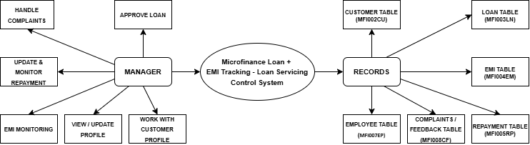

5.3. CUSTOMER
Level – 1

Level – 2
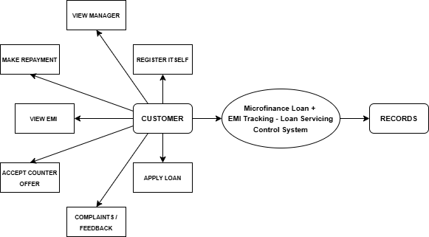
Level – 3
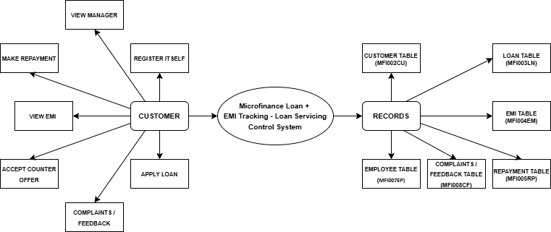

5: Screen Designs
5.1 Login Module
5.1.1: Login Screen
 | 12345678901234567890123456789012345678901234567890123456789012345678901234567890
1  2  3  4  5  6  7  8  9  10  11  12  13  14  15  16  17  18  19  20  21  22  23  24 | WELCOME 00000000000000000000000000 DATE  USER TIME  LOGIN  LOGIN ID…………... BBBBBB  PASSWORD……….. BBBBBBBBBB  F3=Exit F5= Refresh F6=New Registration F9=Forgot Password  (Error Message)

Functionalities and Validations:
Header:
- The name of the bank that appears in the output mode is directly fetched from the data area for all the screens.
- And Date, time, System Name and Username should be auto populated when user comes to this page.
Login Id:
- Data type for the login ID must be character of size 6.
- The Login ID must contain a prefix of characters, followed by numeric digits. For customers, the format is ‘ANNNNN’, and for employees, the format is ‘AANNNN’
Password:
- Data type for the password must be character of size 10.
- Password is a non-display field.
- Encryption of the password.
Footer:
- F3 function key for exit this page.
- F5 function key is used for refreshing the page.
- F6 function key for registering the new user for login.
- F9 function key if user forgot the password, then user can continue to login by changing the password.
5.1.2: New Customer Registration
 | 12345678901234567890123456789012345678901234567890123456789012345678901234567890
1  2  3  4  5  6  7  8  9  10  11  12  13  14  15  16  17  18  19  20  21  22  23  24 | WELCOME 0000000000000000000000000000 DATE  USER TIME  New Customer Registration  User Id……: BBBBBB  Name……..: BBBBBBBBBBBBBBBBBBBBBBBBBBBBBB DOB……………: BBBB/BB/BB (YYYY/MM/DD)  Phone No.: BBBBBBBBBB PAN Number.: BBBBBBBBBB  Email………: BBBBBBBBBBBBBBBBBBBBBBBBBBBBBBBBBBBBBBBB Gender..: B(F4)  State……….: BBBBBBBBBBBBBBBBBBBB (F4) Pin code: 999999  City…..…….: BBBBBBBBBBBBBBBBBBBB  Address…..: BBBBBBBBBBBBBBBBBBBBBBBBBBBBBBBBBBBBBBBB  BBBBBBBBBBBBBBBBBBBBBBBBBBBBBBBBBBBBBBBB  Password..: BBBBBBBBBB  Confirm Password: BBBBBBBBBB  Security Question: BBBBBBBBBBBBBBBBBBBBBBBBBBBBBBBBBBBBBBBBBBBBBBBBBB (F4)  Security Answer...: BBBBBBBBBBBBBBBBBBBBBBBBBBBBBBBBBBBBBBBBBBBBBBBBBB  F3=Exit F4=Prompt F5=Refresh F6=Register F12=Cancel  (Error Message)

Functions and Validation: -

- ID will be auto generated
- Name and city will not have numeric or special characters.
- DOB should be valid and should not be a future date.
- Gender and State will be selected by Prompt.
- Mobile numbers should not start with zero, must contain 10 digits, and should only contain numeric values.
- PAN Number should be in a format AAAAANNNNA.
- Password should be of minimum 8 characters and must contain a special char, one uppercase letter, one lowercase letter, and one digit.
- Email should contain only one @ symbol and one domain name and should only start with the alphabet.
- Status of newly registered customers will always be active.
- Pressing F3 will exit from the program, F4 will open prompt window, F5 will reset the screen, F6 will register new customer and F12 will cancel this process.

5.1.3: Forgot Password
 | 12345678901234567890123456789012345678901234567890123456789012345678901234567890
1  2  3  4  5  6  7  8  9  10  11  12  13  14  15  16  17  18  19  20  21  22  23  24 | WELCOME 0000000000000000000000000000 DATE  USER TIME  Forgot Password  Login Id……………..: BBBBBB  Security Question: OOOOOOOOOOOOOOOOOOOOOOOOOOOOOOOOOOOOOOOOOOOOOOOOOO  Security Answer...: BBBBBBBBBBBBBBBBBBBBBBBBBBBBBBBBBBBBBBBBBBBBBBBBBBBBBBBBBBBBB  New Password……: BBBBBBBBBB  Confirm Password: BBBBBBBBBB  F3=Exit F5=Refresh F6=Change Password F12=Cancel  (Error Message)

Functions and Validation: -

- The user will enter their Login Id here and then if the Login Id is found in the database, then the security question will be visible, and user must input their correct answer after that user can change their password.
- Pressing F3 will exit from the program, F5 will reset the screen, F6 will change password and F12 will cancel this process

5.1.3: Change Password & Add Security Question
 | 12345678901234567890123456789012345678901234567890123456789012345678901234567890
1  2  3  4  5  6  7  8  9  10  11  12  13  14  15  16  17  18  19  20  21  22  23  24 | WELCOME 0000000000000000000000000000 DATE  USER TIME  Change Password & Add Security Question  Login Id……………..: OOOOOO  New Password……: BBBBBBBBBB  Confirm Password: BBBBBBBBBB  Security Question: BBBBBBBBBBBBBBBBBBBBBBBBBBBBBBBBBBBBBBBBBBBBBBBBBBBBBBBB (F4)  Security Answer...: BBBBBBBBBBBBBBBBBBBBBBBBBBBBBBBBBBBBBBBBBBBBBBBBBBBBBBBBBBBBB  F3=Exit F4=Prompt F5=Refresh F6=Update F12=Cancel  (Error Message)

Functions and Validation: -

When a new admin or manager logs in for the very first time, the system forces them to change their password and then set a security question and answer.
- Pressing F3 will exit from the program, F4 will open prompt window, F5 will reset the screen, F6 will update their changes and F12 will cancel this process.

5.2 Admin Module

5.2.1: Admin Dashboard
 | 12345678901234567890123456789012345678901234567890123456789012345678901234567890
1  2  3  4  5  6  7  8  9  10  11  12  13  14  15  16  17  18  19  20  21  22  23  24 | WELCOME 0000000000000000000000000000 DATE  USER TIME  Admin Dashboard  Type Choice, Press Enter  - Manage Employees  - View Customers Loans  - View Customers EMI’s & Repayments  - Loan Rules  - View Complaints / Feedback  - View Reports  Enter Choice: 9  F3=Exit F5=Refresh F12=Logout  (Error Message)

Functionalities and Validations: -

- Admin will enter choices as 1,2,3,4,5 and 6 to go to the next screen and if hit other than this then an error will be given.

- F3 to exit, F5 for refresh and F12 for Logout.

5.2.2: Manage Employees
 | 12345678901234567890123456789012345678901234567890123456789012345678901234567890
1  2  3  4  5  6  7  8  9  10  11  12  13  14  15  16  17  18  19  20  21  22  23  24 | WELCOME 0000000000000000000000000000 DATE  USER TIME  Manage Employees  Type Choice, Press Enter Position To: BBBBBBBBBB  2=Update 4=Inactive 5=Display  Opt Employee Id Name Phone No. Status  99 OOOOOO OOOOOOOOOOOOOOOOOOOOOOOOOOOOOO OOOOOOOOOO OOOOOOOOOO  99 OOOOOO OOOOOOOOOOOOOOOOOOOOOOOOOOOOOO OOOOOOOOOO OOOOOOOOOO  99 OOOOOO OOOOOOOOOOOOOOOOOOOOOOOOOOOOOO OOOOOOOOOO OOOOOOOOOO  99 OOOOOO OOOOOOOOOOOOOOOOOOOOOOOOOOOOOO OOOOOOOOOO OOOOOOOOOO  99 OOOOOO OOOOOOOOOOOOOOOOOOOOOOOOOOOOOO OOOOOOOOOO OOOOOOOOOO  99 OOOOOO OOOOOOOOOOOOOOOOOOOOOOOOOOOOOO OOOOOOOOOO OOOOOOOOOO  99 OOOOOO OOOOOOOOOOOOOOOOOOOOOOOOOOOOOO OOOOOOOOOO OOOOOOOOOO  99 OOOOOO OOOOOOOOOOOOOOOOOOOOOOOOOOOOOO OOOOOOOOOO OOOOOOOOOO  More  F3=Exit F4=Active/Inactive F5=Refresh F6=Add New Employee F12=Cancel  (Error Message)

Functionality and Validations: -
- Admin can take choice as 2 for Update, and 5 to display against Opt field of any employee to perform that operation.
- Admin can add a new employee by pressing F6.
- Admin can press F4 to list only active employees or inactive employees.
- If the admin puts any choice other than 2,5 then an error will be given with the field highlighted.
- F3 to exit, F5 for refresh and F12 for Cancel.

5.2.2.1: New Employee Registration
 | 12345678901234567890123456789012345678901234567890123456789012345678901234567890
1  2  3  4  5  6  7  8  9  10  11  12  13  14  15  16  17  18  19  20  21  22  23  24 | WELCOME 0000000000000000000000000000 DATE  USER TIME  New Employee Registration  Employee Id….: OOOOOO  Name……..: BBBBBBBBBBBBBBBBBBBBBBBBBBBBBB DOB……………: BBBB/BB/BB (YYYY/MM/DD)  Phone No.: BBBBBBBBBB Gender……….: B(F4)  Email………: BBBBBBBBBBBBBBBBBBBBBBBBBBBBBBBBBBBBBBBB  State……….: BBBBBBBBBBBBBBBBBBBB (F4) Pin code…….: 999999  City…..…….: BBBBBBBBBBBBBBBBBBBB Role……………: BBBBBBBBBB (F4)  Address…..: BBBBBBBBBBBBBBBBBBBBBBBBBBBBBBBBBBBBBBBB  BBBBBBBBBBBBBBBBBBBBBBBBBBBBBBBBBBBBBBBB  F3=Exit F4=Prompt F5=Refresh F6=Register F12=Cancel  (Error Message)

Functionality and Validations: -
- Employee ID should be system generated.
- Name should contain characters only.
- DOB should be in valid YYYY/MM/DD format, not greater than current date, and age must be ≥ 18 years.
- Phone number should be numeric, 10 digits, and should not start with zero.
- Gender should be a protected field and selectable using F4 prompt.
- Email ID should be in a valid email format.
- State should be a protected field and selectable using F4 prompt.
- Pin code should be numeric only and of valid length, 6 digits.
- City should contain characters only.
- Role should be a protected field and selectable using F4 prompt.
- Address should not be blank and should be within the defined length.
- Status of newly registered employees will always be active.
- DOJ will be auto fetched as current date when new employee is added
- System generated passwords will be sent to employees for logging in first time.
- Pressing F3 will exit from the program, F4 will open prompt window, F5 will reset the screen, F6 will register new employees and F12 will cancel this process.

5.2.2.2 Update Employee Detail
 | 12345678901234567890123456789012345678901234567890123456789012345678901234567890
1  2  3  4  5  6  7  8  9  10  11  12  13  14  15  16  17  18  19  20  21  22  23  24 | WELCOME 0000000000000000000000000000 DATE  USER TIME  Update Employee Detail  Employee Id….: OOOOOO  Name……..: BBBBBBBBBBBBBBBBBBBBBBBBBBBBBB DOB……………: BBBB/BB/BB (YYYY/MM/DD)  Phone No.: BBBBBBBBBB Gender……….: B(F4)  Email………: BBBBBBBBBBBBBBBBBBBBBBBBBBBBBBBBBBBBBBBB  State……….: BBBBBBBBBBBBBBBBBBBB (F4) Pin code…….: 999999  City…..…….: BBBBBBBBBBBBBBBBBBBB Role……………: BBBBBBBBBB (F4)  Address…..: BBBBBBBBBBBBBBBBBBBBBBBBBBBBBBBBBBBBBBBB  BBBBBBBBBBBBBBBBBBBBBBBBBBBBBBBBBBBBBBBB  Status……..: BBBBBBBBBB (F4)  F3=Exit F4=Prompt F5=Refresh F6=Update F12=Cancel  (Error Message)

Functionality and Validations: -
- Name should contain characters only.
- DOB should be in valid YYYY/MM/DD format, not greater than current date, and age must be ≥ 18 years.
- Phone number should be numeric, 10 digits, and should not start with zero.
- Gender should be a protected field and selectable using F4 prompt.
- Email ID should be in a valid email format.
- State should be a protected field and selectable using F4 prompt.
- Pin code should be numeric only and of valid length, 6 digits.
- City should contain characters only.
- Role should be a protected field and selectable using F4 prompt.
- Address should not be blank and should be within the defined length.
- Status should be a protected field and selectable using F4 prompt.
- Pressing F3 will exit from the program, F4 will open prompt window, F5 will reset the screen, F6 will update details and F12 will cancel this process.

5.2.2.3: View Employee Detail
 | 12345678901234567890123456789012345678901234567890123456789012345678901234567890
1  2  3  4  5  6  7  8  9  10  11  12  13  14  15  16  17  18  19  20  21  22  23  24 | WELCOME 0000000000000000000000000000 DATE  USER TIME  View Employee Detail  Employee Id….: OOOOOO  Name……………: OOOOOOOOOOOOOOOOOOOOOOOOOOOOOO  DOB………………: OOOO/OO/OO (YYYY/MM/DD) DOJ……….…: OOOO/OO/OO (YYYY/MM/DD)  Phone No……..: OOOOOOOOOO Gender…….: OOOOOOOOOO  Email…………….: OOOOOOOOOOOOOOOOOOOOOOOOOOOOOOOOOOOOOOOO  State…………….: OOOOOOOOOOOOOOOOOOOO Pin code…..: 666666  City…..………….: OOOOOOOOOOOOOOOOOOOO Role………….: OOOOOOOOOO  Address………..: OOOOOOOOOOOOOOOOOOOOOOOOOOOOOOOOOOOOOOOO  OOOOOOOOOOOOOOOOOOOOOOOOOOOOOOOOOOOOOOOO  Status…………..: OOOOOOOOOO  F3=Exit F12=Cancel  (Error Message)

Functionality and Validation: -

- Admin can view detailed information about employees.
- All the fields here are non-editable.
- Pressing F3 will exit from the program and F12 will cancel this process.

5.2.3: View Customer Loans
 | 12345678901234567890123456789012345678901234567890123456789012345678901234567890
1  2  3  4  5  6  7  8  9  10  11  12  13  14  15  16  17  18  19  20  21  22  23  24 | WELCOME 0000000000000000000000000000 DATE  USER TIME  View Customers Loans  Type Choice, Press Enter Position To: BBBBBBBBBB  5=Display  Opt Loan Id Customer Id Name Status  99 OOOOOO OOOOOO OOOOOOOOOOOOOOOOOOOOOOOOOOOOOO OOOOOOOOOOO  99 OOOOOO OOOOOO OOOOOOOOOOOOOOOOOOOOOOOOOOOOOO OOOOOOOOOOO  99 OOOOOO OOOOOO OOOOOOOOOOOOOOOOOOOOOOOOOOOOOO OOOOOOOOOOO  99 OOOOOO OOOOOO OOOOOOOOOOOOOOOOOOOOOOOOOOOOOO OOOOOOOOOOO  99 OOOOOO OOOOOO OOOOOOOOOOOOOOOOOOOOOOOOOOOOOO OOOOOOOOOOO  99 OOOOOO OOOOOO OOOOOOOOOOOOOOOOOOOOOOOOOOOOOO OOOOOOOOOOO  99 OOOOOO OOOOOO OOOOOOOOOOOOOOOOOOOOOOOOOOOOOO OOOOOOOOOOO  99 OOOOOO OOOOOO OOOOOOOOOOOOOOOOOOOOOOOOOOOOOO OOOOOOOOOOO  More  F3=Exit F4=Pending/Approved/Rejected/Closed F5=Refresh F12=Cancel  (Error Message)

Functionality and Validation: -

- Admin can view loan details taking 5 in opt field.
- All the fields here are non-editable except position to for searching.
- Admin can press F4 to list pending, approved, rejected or closed loans.
- Pressing F3 will exit from the program, F5 will reset the screen, F6 will update details and F12 will cancel this process.

5.2.3.1: View Customer Loan Detail
 | 12345678901234567890123456789012345678901234567890123456789012345678901234567890
1  2  3  4  5  6  7  8  9  10  11  12  13  14  15  16  17  18  19  20  21  22  23  24 | WELCOME 0000000000000000000000000000 DATE  USER TIME  View Customer Loan Detail  Customer Id….: OOOOOO Loan Id…….: OOOOOO Approved By: OOOOOO  Name……….: OOOOOOOOOOOOOOOOOOOOOOOOOOOOOO  DOB………….: OOOO/OO/OO (YYYY/MM/DD)  Phone No...: OOOOOOOOOO Gender…….: OOOOOOOOOO  Email……….: OOOOOOOOOOOOOOOOOOOOOOOOOOOOOOOOOOOOOOOO  State………..: OOOOOOOOOOOOOOOOOOOO Pin code…..: 666666  City…..……..: OOOOOOOOOOOOOOOOOOOO Customer Status……..: OOOOOOOOOO  Address…...: OOOOOOOOOOOOOOOOOOOOOOOOOOOOOOOOOOOOOOOO  OOOOOOOOOOOOOOOOOOOOOOOOOOOOOOOOOOOOOOOO  Loan Requested Amount: 66666666.66 Loan Approved Amount: 66666666.66  Interest: 666.66 Tenure: 666 DSR (%): 666.66 Monthly EMI.: 66666666.66  Start Date.: OOOO/OO/OO (YYYY/MM/DD) End Date.: OOOO/OO/OO (YYYY/MM/DD)  Loan Status: OOOOOOOOOO  F3=Exit F12=Cancel  (Error Message)

Functionality and Validation: -

- Admin can view detailed information about a loan.
- All the fields here are non-editable.
- Pressing F3 will exit from the program and F12 will cancel this process.

5.2.4: View EMI’s & Repayments
 | 12345678901234567890123456789012345678901234567890123456789012345678901234567890
1  2  3  4  5  6  7  8  9  10  11  12  13  14  15  16  17  18  19  20  21  22  23  24 | WELCOME 0000000000000000000000000000 DATE  USER TIME  View EMI’s & Repayments  Type Choice, Press Enter  - View EMI’s  - View Repayments  Enter Choice: 9  F3=Exit F5=Refresh F12=Cancel  (Error Message)

Functionalities and Validations: -

- Admin will enter choices as 1 and 2 to go to the next screen and if hit other than this then an error will be given.
- F3 to exit, F5 for refresh and F12 for Cancel.

5.2.4.1: View EMI’s
 | 12345678901234567890123456789012345678901234567890123456789012345678901234567890
1  2  3  4  5  6  7  8  9  10  11  12  13  14  15  16  17  18  19  20  21  22  23  24 | WELCOME 0000000000000000000000000000 DATE  USER TIME  View EMI’s  Enter Loan Id: BBBBBB  F3=Exit F5=Refresh F12=Cancel  (Error Message)

Functionalities and Validations: -

- Admin will enter loan id to view the previous paid emi’s and upcoming EMI
- F3 to exit, F5 for refresh and F12 for Cancel.

5.2.4.2: EMI’s
 | 12345678901234567890123456789012345678901234567890123456789012345678901234567890
1  2  3  4  5  6  7  8  9  10  11  12  13  14  15  16  17  18  19  20  21  22  23  24 | WELCOME 0000000000000000000000000000 DATE  USER TIME  EMI’s  Type Choice, Press Enter Position To: BBBBBBBBBB  5=Display  Opt EMI Id Loan Id Customer Id Status  99 OOOOOO OOOOOO OOOOOO OOOOOOOOOO  99 OOOOOO OOOOOO OOOOOO OOOOOOOOOO  99 OOOOOO OOOOOO OOOOOO OOOOOOOOOO  99 OOOOOO OOOOOO OOOOOO OOOOOOOOOO  99 OOOOOO OOOOOO OOOOOO OOOOOOOOOO 99 OOOOOO OOOOOO OOOOOO OOOOOOOOOO  99 OOOOOO OOOOOO OOOOOO OOOOOOOOOO  99 OOOOOO OOOOOO OOOOOO OOOOOOOOOO  More  F3=Exit F4=Paid/Unpaid F5=Refresh F12=Cancel  (Error Message)

Functionality and Validation: -

- Admin can view EMI details taking 5 in opt field.
- All the fields here are non-editable except position to for searching.
- Admin can press F4 to list paid and unpaid.
- Pressing F3 will exit from the program, F5 will reset the screen and F12 will cancel this process.

5.2.4.3: View EMI Detail
 | 12345678901234567890123456789012345678901234567890123456789012345678901234567890
1  2  3  4  5  6  7  8  9  10  11  12  13  14  15  16  17  18  19  20  21  22  23  24 | WELCOME 0000000000000000000000000000 DATE  USER TIME  View EMI Detail  Customer Id….: OOOOOO EMI Id: OOOOOO Loan Id…….: OOOOOO  Name……..: OOOOOOOOOOOOOOOOOOOOOOOOOOOOOO  Phone No.: OOOOOOOOOO  EMI…………: 66666666.66  Due/Paid Date: OOOO/OO/OO (YYYY/MM/DD)  Status……..: OOOOOOOOOO  F3=Exit F12=Cancel  (Error Message)

Functionality and Validation: -

- Admin can view detailed information about an EMI.
- All the fields here are non-editable.
- Pressing F3 will exit from the program and F12 will cancel this process.

5.2.4.4: Repayments
 | 12345678901234567890123456789012345678901234567890123456789012345678901234567890
1  2  3  4  5  6  7  8  9  10  11  12  13  14  15  16  17  18  19  20  21  22  23  24 | WELCOME 0000000000000000000000000000 DATE  USER TIME  Repayments  Type Choice, Press Enter Position To: BBBBBBBBBB  5=Display  Opt Repayment Id EMI Id Loan Id Customer Id Status  99 OOOOOO OOOOOO OOOOOO OOOOOO OOOOOOOOOO  99 OOOOOO OOOOOO OOOOOO OOOOOO OOOOOOOOOO  99 OOOOOO OOOOOO OOOOOO OOOOOO OOOOOOOOOO  99 OOOOOO OOOOOO OOOOOO OOOOOO OOOOOOOOOO  99 OOOOOO OOOOOO OOOOOO OOOOOO OOOOOOOOOO 99 OOOOOO OOOOOO OOOOOO OOOOOO OOOOOOOOOO  99 OOOOOO OOOOOO OOOOOO OOOOOO OOOOOOOOOO  99 OOOOOO OOOOOO OOOOOO OOOOOO OOOOOOOOOO  More  F3=Exit F4=Pending/Hold/Successful/Failed F5=Refresh F12=Cancel  (Error Message)

Functionality and Validation: -

- Admin can view repayment details taking 5 in opt field.
- All the fields here are non-editable except position to for searching.
- Admin can press F4 to list pending, hold, successful and failed.
- Pressing F3 will exit from the program, F5 will reset the screen and F12 will cancel this process.

5.2.4.5: View Repayment Detail
 | 12345678901234567890123456789012345678901234567890123456789012345678901234567890
1  2  3  4  5  6  7  8  9  10  11  12  13  14  15  16  17  18  19  20  21  22  23  24 | WELCOME 0000000000000000000000000000 DATE  USER TIME  View Repayment Detail  Customer Id….: OOOOOO Repayment Id: OOOOOO EMI Id: OOOOOO Loan Id…….: OOOOOO  Name……........: OOOOOOOOOOOOOOOOOOOOOOOOOOOOOO  Phone No.......: OOOOOOOOOO  Repayment....: 66666666.66  Due Date........: OOOO/OO/OO (YYYY/MM/DD)  Status……........: OOOOOOOOOO  F3=Exit F12=Cancel  (Error Message)

Functionality and Validation: -

- Admin can view detailed information about a repaymentI.
- All the fields here are non-editable.
- Pressing F3 will exit from the program and F12 will cancel this process.

5.2.5: Loan Rules
 | 12345678901234567890123456789012345678901234567890123456789012345678901234567890
1  2  3  4  5  6  7  8  9  10  11  12  13  14  15  16  17  18  19  20  21  22  23  24 | WELCOME 0000000000000000000000000000 DATE  USER TIME  Loan Rules  Type Choice, Press Enter Position To: BBBBBBBBBB  2=Update 5=Display  Opt Rule Id Admin Id Status  99 OOOOOO OOOOOO OOOOOOOOOO  99 OOOOOO OOOOOO OOOOOOOOOO  99 OOOOOO OOOOOO OOOOOOOOOO  99 OOOOOO OOOOOO OOOOOOOOOO  99 OOOOOO OOOOOO OOOOOOOOOO  99 OOOOOO OOOOOO OOOOOOOOOO  99 OOOOOO OOOOOO OOOOOOOOOO  99 OOOOOO OOOOOO OOOOOOOOOO  More  F3=Exit F4=Active/Inactive F5=Refresh F6=Add New Rule F12=Cancel  (Error Message)

Functionality and Validations: -
- Admin can take choice as 2 for Update, and 5 to display against Opt field of any employee to perform that operation.
- Admin can add a new rule by pressing F6.
- Admin can press F4 to list only active rules or inactive rules.
- If the admin puts any choice other than 2,5 then an error will be given with the field highlighted.
- F3 to exit, F5 for refresh and F12 for Cancel.

5.2.5.1: New Loan Rule
 | 12345678901234567890123456789012345678901234567890123456789012345678901234567890
1  2  3  4  5  6  7  8  9  10  11  12  13  14  15  16  17  18  19  20  21  22  23  24 | WELCOME 0000000000000000000000000000 DATE  USER TIME  New Rule  Rule Id…….............: OOOOOO Admin Id................: OOOOOO  Minimum Amount: 99999999.99 Maximum Amount: 99999999.99  Minimum Interest.: 999.99 Maximum Interest: 999.99  Minimum Tenure..: 999 Maximum Tenure..: 999  Processing Fees....: 999.99  F3=Exit F5=Refresh F6=Register F12=Cancel  (Error Message)

Functions and Validation: -

- Rule ID should be system generated
- Admin ID should be mandatory and must exist in Employee Table.
- Minimum Amount should be numeric, allow 2 decimals, and greater than or equal to zero.
- Maximum Amount should be numeric, allow 2 decimals, and greater than or equal to Minimum Amount.
- Minimum Interest should be numeric, allow 2 decimals, and must be in the range 0 to 100.
- Maximum Interest should be numeric, allow 2 decimals, and greater than or equal to Minimum Interest.
- Minimum Tenure should be numeric, in months, and greater than zero.
- Maximum Tenure should be numeric, in months, and greater than or equal to Minimum Tenure.
- Processing Fees should be numeric, allow 2 decimals, and greater than or equal to zero.
- Status of newly registered rules will always be active.
- All numeric fields must reject alphabetic and special characters.
- Pressing F3 will exit from the program, F5 will reset the screen, F6 will register new rules and F12 will cancel this process.

5.2.5.2: Update Loan Rule
 | 12345678901234567890123456789012345678901234567890123456789012345678901234567890
1  2  3  4  5  6  7  8  9  10  11  12  13  14  15  16  17  18  19  20  21  22  23  24 | WELCOME 0000000000000000000000000000 DATE  USER TIME  Update Rule  Rule Id…….............: OOOOOO Admin Id................: OOOOOO  Minimum Amount: 99999999.99 Maximum Amount: 99999999.99  Minimum Interest.: 999.99 Maximum Interest: 999.99  Minimum Tenure..: 999 Maximum Tenure..: 999  Processing Fees....: 999.99  Status...................: BBBBBBBBBB (F4)  F3=Exit F4=Prompt F5=Refresh F6=Register F12=Cancel  (Error Message)

Functions and Validation: -

- Minimum Amount should be numeric, allow 2 decimals, and greater than or equal to zero.
- Maximum Amount should be numeric, allow 2 decimals, and greater than or equal to Minimum Amount.
- Minimum Interest should be numeric, allow 2 decimals, and must be in the range 0 to 100.
- Maximum Interest should be numeric, allow 2 decimals, and greater than or equal to Minimum Interest.
- Minimum Tenure should be numeric, in months, and greater than zero.
- Maximum Tenure should be numeric, in months, and greater than or equal to Minimum Tenure.
- Processing Fees should be numeric, allow 2 decimals, and greater than or equal to zero.
- All numeric fields must reject alphabetic and special characters.
- Status should be a protected field and selectable using F4 prompt.
- Pressing F3 will exit from the program, F4 will open prompt window, F5 will reset the screen, F6 will update details and F12 will cancel this process.

5.2.5.2: View Loan Rule
 | 12345678901234567890123456789012345678901234567890123456789012345678901234567890
1  2  3  4  5  6  7  8  9  10  11  12  13  14  15  16  17  18  19  20  21  22  23  24 | WELCOME 0000000000000000000000000000 DATE  USER TIME  View Rule  Rule Id…….............: OOOOOO Admin Id................: OOOOOO  Minimum Amount: 66666666.66 Maximum Amount: 66666666.66  Minimum Interest.: 666.66 Maximum Interest: 666.66  Minimum Tenure..: 666 Maximum Tenure..: 666  Processing Fees....: 666.66  Status...................: OOOOOOOOOO  F3=Exit F12=Cancel  (Error Message)

Functionality and Validation: -

- Admin can view detailed information about a loan rule.
- All the fields here are non-editable.
- Pressing F3 will exit from the program and F12 will cancel this process.

5.2.6: Complaints & Feedback
 | 12345678901234567890123456789012345678901234567890123456789012345678901234567890
1  2  3  4  5  6  7  8  9  10  11  12  13  14  15  16  17  18  19  20  21  22  23  24 | WELCOME 0000000000000000000000000000 DATE  USER TIME  Complaints & Feedback  Type Choice, Press Enter Position To: BBBBBBBBBB  5=Display  Opt Ticket Id Customer Id Loan Id Type  99 OOOOOO OOOOOO OOOOOO OOOOOOOOOO  99 OOOOOO OOOOOO OOOOOO OOOOOOOOOO  99 OOOOOO OOOOOO OOOOOO OOOOOOOOOO  99 OOOOOO OOOOOO OOOOOO OOOOOOOOOO  99 OOOOOO OOOOOO OOOOOO OOOOOOOOOO  99 OOOOOO OOOOOO OOOOOO OOOOOOOOOO  99 OOOOOO OOOOOO OOOOOO OOOOOOOOOO  99 OOOOOO OOOOOO OOOOOO OOOOOOOOOO  More  F3=Exit F4=Complaint & Feedback F5=Refresh F12=Cancel  (Error Message)

Functionality and Validation: -

- Admin can view complaints & feedback taking 5 in opt field
- All the fields here are non-editable except position to for searching.
- Admin can press F4 to list complaints & feedbacks.
- Pressing F3 will exit from the program, F5 will reset the screen and F12 will cancel this process.

5.2.6.1: View Feedback
 | 12345678901234567890123456789012345678901234567890123456789012345678901234567890
1  2  3  4  5  6  7  8  9  10  11  12  13  14  15  16  17  18  19  20  21  22  23  24 | WELCOME 0000000000000000000000000000 DATE  USER TIME  View Feedback  Customer Id….: OOOOOO  Ticket Id..........: OOOOOO  Loan Id............: OOOOOO  Employee Id....: OOOOOO  Description.....: OOOOOOOOOOOOOOOOOOOOOOOOOOOOOOOOOOOOOOOOOOOOOOOOOO  OOOOOOOOOOOOOOOOOOOOOOOOOOOOOOOOOOOOOOOOOOOOOOOOOO  F3=Exit F12=Cancel  (Error Message)

Functionality and Validation: -

- Admin can view detailed information about a feedback.
- All the fields here are non-editable.
- Pressing F3 will exit from the program and F12 will cancel this process.

5.2.6.2: View Complaint
 | 12345678901234567890123456789012345678901234567890123456789012345678901234567890
1  2  3  4  5  6  7  8  9  10  11  12  13  14  15  16  17  18  19  20  21  22  23  24 | WELCOME 0000000000000000000000000000 DATE  USER TIME  View Complaint  Customer Id….: OOOOOO  Ticket Id..........: OOOOOO  Loan Id............: OOOOOO  Employee Id....: OOOOOO  Description.....: OOOOOOOOOOOOOOOOOOOOOOOOOOOOOOOOOOOOOOOOOOOOOOOOOO  OOOOOOOOOOOOOOOOOOOOOOOOOOOOOOOOOOOOOOOOOOOOOOOOOO  Status.............: OOOOOOOOOO  F3=Exit F12=Cancel  (Error Message)

Functionality and Validation: -

- Admin can view detailed information about a complaint.
- All the fields here are non-editable.
- Pressing F3 will exit from the program and F12 will cancel this process.

5.2.7.1: View Reports
 | 12345678901234567890123456789012345678901234567890123456789012345678901234567890
1  2  3  4  5  6  7  8  9  10  11  12  13  14  15  16  17  18  19  20  21  22  23  24 | WELCOME 0000000000000000000000000000 DATE  USER TIME  View Reports  Start Date: BBBB/BB/BB (YYYY/MM/DD)  End Date.: BBBB/BB/BB (YYYY/MM/DD)  F3=Exit F12=Cancel  (Error Message)

Functionality and Validation: -

- Admin will enter start date and end date to find reports between those dates.
- Pressing F3 will exit from the program and F12 will cancel this process.

5.2.7.1: Reports
 | 12345678901234567890123456789012345678901234567890123456789012345678901234567890
1  2  3  4  5  6  7  8  9  10  11  12  13  14  15  16  17  18  19  20  21  22  23  24 | WELCOME 0000000000000000000000000000 DATE  USER TIME  Reports  No. Of Customers Joined..............: 666666  No. Of Employees Joined..............: 666666  Total Loan Provided......................: 66666666.66  Total No. of Loans Provided..........: 666666  Total EMI’s Paid............................: 66666666.66  Total Repayments Pending...........: 66666666.66  F3=Exit F12=Cancel  (Error Message)

Functionality and Validation: -

- Admin can view reports.
- All the fields here are non-editable.
- Pressing F3 will exit from the program and F12 will cancel this process.

5.3 Manager Module

5.3.1: Manager Dashboard
 | 12345678901234567890123456789012345678901234567890123456789012345678901234567890
1  2  3  4  5  6  7  8  9  10  11  12  13  14  15  16  17  18  19  20  21  22  23  24 | WELCOME 0000000000000000000000000000 DATE  USER TIME  Manager Dashboard  Type Choice, Press Enter  1. View/Update Profile  2. View Customer Profile  3. Approve Loans  4. View EMI’s  5. Update Repayments  6. View Complaints  Enter Choice: 9  F3=Exit F5=Refresh F12=Logout  (Error Message)

Functionalities and Validations: -

- Manager will enter choices as 1,2,3,4,5 and 6 to go to the next screen and if hit other than this then an error will be given.
- F3 to exit, F5 for refresh and F12 for Logout.

5.3.2: View/Update Profile
 | 12345678901234567890123456789012345678901234567890123456789012345678901234567890
1  2  3  4  5  6  7  8  9  10  11  12  13  14  15  16  17  18  19  20  21  22  23  24 | WELCOME 0000000000000000000000000000 DATE  USER TIME  View/Update Profile  Type Choice, Press Enter  - View Profile  - Update Profile  Enter Choice: 9  F3=Exit F5=Refresh F12=Cancel  (Error Message)

Functionalities and Validations: -

- Manager will enter choices as 1 and 2 to go to the next screen and if hit other than this then an error will be given.
- F3 to exit, F5 for refresh and F12 for Cancel.

5.3.2.1: View Profile
 | 12345678901234567890123456789012345678901234567890123456789012345678901234567890
1  2  3  4  5  6  7  8  9  10  11  12  13  14  15  16  17  18  19  20  21  22  23  24 | WELCOME 0000000000000000000000000000 DATE  USER TIME  View Profile  Employee Id….: OOOOOO  Name……………: OOOOOOOOOOOOOOOOOOOOOOOOOOOOOO  DOB………………: OOOO/OO/OO (YYYY/MM/DD) DOJ……….…: OOOO/OO/OO (YYYY/MM/DD)  Phone No……..: OOOOOOOOOO Gender…….: OOOOOOOOOO  Email…………….: OOOOOOOOOOOOOOOOOOOOOOOOOOOOOOOOOOOOOOOO  State…………….: OOOOOOOOOOOOOOOOOOOO Pin code…..: 666666  City…..………….: OOOOOOOOOOOOOOOOOOOO  Address………..: OOOOOOOOOOOOOOOOOOOOOOOOOOOOOOOOOOOOOOOO  OOOOOOOOOOOOOOOOOOOOOOOOOOOOOOOOOOOOOOOO  F3=Exit F12=Cancel  (Error Message)

Functionality and Validation: -

- Managers can view detailed information about their profile.
- All the fields here are non-editable.
- Pressing F3 will exit from the program and F12 will cancel this process.

5.3.2.2 Update Detail
 | 12345678901234567890123456789012345678901234567890123456789012345678901234567890
1  2  3  4  5  6  7  8  9  10  11  12  13  14  15  16  17  18  19  20  21  22  23  24 | WELCOME 0000000000000000000000000000 DATE  USER TIME  Update Profile  Employee Id….: OOOOOO  Name……..: BBBBBBBBBBBBBBBBBBBBBBBBBBBBBB DOB……………: BBBB/BB/BB (YYYY/MM/DD)  Phone No.: BBBBBBBBBB Gender……….: B(F4)  Email………: BBBBBBBBBBBBBBBBBBBBBBBBBBBBBBBBBBBBBBBB  State……….: BBBBBBBBBBBBBBBBBBBB (F4) Pin code…….: 999999  City…..…….: BBBBBBBBBBBBBBBBBBBB  Address…..: BBBBBBBBBBBBBBBBBBBBBBBBBBBBBBBBBBBBBBBB  BBBBBBBBBBBBBBBBBBBBBBBBBBBBBBBBBBBBBBBB  F3=Exit F4=Prompt F5=Refresh F6=Update F12=Cancel  (Error Message)

Functionality and Validations: -
- Name should contain characters only.
- DOB should be in valid YYYY/MM/DD format, not greater than current date, and age must be ≥ 18 years.
- Phone number should be numeric, 10 digits, and should not start with zero.
- Gender should be a protected field and selectable using F4 prompt.
- Email ID should be in a valid email format.
- State should be a protected field and selectable using F4 prompt.
- Pin code should be numeric only and of valid length, 6 digits.
- City should contain characters only.
- Address should not be blank and should be within the defined length.
- Pressing F3 will exit from the program, F4 will open prompt window, F5 will reset the screen, F6 will update details and F12 will cancel this process.

5.3.3: View Customers
 | 12345678901234567890123456789012345678901234567890123456789012345678901234567890
1  2  3  4  5  6  7  8  9  10  11  12  13  14  15  16  17  18  19  20  21  22  23  24 | WELCOME 0000000000000000000000000000 DATE  USER TIME  View Customers  Type Choice, Press Enter Position To: BBBBBBBBBB  5=Display  Opt Customer Id Name Status  99 OOOOOO OOOOOOOOOOOOOOOOOOOOOOOOOOOOOO OOOOOOOOOOO  99 OOOOOO OOOOOOOOOOOOOOOOOOOOOOOOOOOOOO OOOOOOOOOOO  99 OOOOOO OOOOOOOOOOOOOOOOOOOOOOOOOOOOOO OOOOOOOOOOO  99 OOOOOO OOOOOOOOOOOOOOOOOOOOOOOOOOOOOO OOOOOOOOOOO  99 OOOOOO OOOOOOOOOOOOOOOOOOOOOOOOOOOOOO OOOOOOOOOOO  99 OOOOOO OOOOOOOOOOOOOOOOOOOOOOOOOOOOOO OOOOOOOOOOO  99 OOOOOO OOOOOOOOOOOOOOOOOOOOOOOOOOOOOO OOOOOOOOOOO  99 OOOOOO OOOOOOOOOOOOOOOOOOOOOOOOOOOOOO OOOOOOOOOOO  More  F3=Exit F4=Active/Inactive F5=Refresh F12=Cancel  (Error Message)

Functionality and Validation: -

- Manager can view loan details taking 5 in opt field.
- All the fields here are non-editable except position to for searching.
- Manager can press F4 to list active/unactive customers.
- Pressing F3 will exit from the program, F5 will reset the screen and F12 will cancel this process.

5.3.3.1: View Customer Profile
 | 12345678901234567890123456789012345678901234567890123456789012345678901234567890
1  2  3  4  5  6  7  8  9  10  11  12  13  14  15  16  17  18  19  20  21  22  23  24 | WELCOME 0000000000000000000000000000 DATE  USER TIME  View Customer Detail  Customer Id….: OOOOOO Loan Id…….: OOOOOO  Name……….: OOOOOOOOOOOOOOOOOOOOOOOOOOOOOO  DOB………….: OOOO/OO/OO (YYYY/MM/DD) DOJ………….: OOOO/OO/OO (YYYY/MM/DD)  Phone No...: OOOOOOOOOO Gender…….: OOOOOOOOOO  Email……….: OOOOOOOOOOOOOOOOOOOOOOOOOOOOOOOOOOOOOOOO  State………..: OOOOOOOOOOOOOOOOOOOO Pin code…..: 666666  City…..……..: OOOOOOOOOOOOOOOOOOOO Customer Status……..: OOOOOOOOOO  Address…...: OOOOOOOOOOOOOOOOOOOOOOOOOOOOOOOOOOOOOOOO  OOOOOOOOOOOOOOOOOOOOOOOOOOOOOOOOOOOOOOOO  Loan Amount......: 66666666.66  Interest: 666.66 Tenure: 666 DSR (%): 666.66 Monthly EMI.: 66666666.66  Start Date... OOOO/OO/OO (YYYY/MM/DD) End Date.: OOOO/OO/OO (YYYY/MM/DD)  Loan Status: OOOOOOOOOO  EMI’s Paid: 666 Repayments Left: 666  F3=Exit F12=Cancel  (Error Message)

Functionality and Validation: -

- Manager can view detailed information about a customer.
- All the fields here are non-editable.
- Pressing F3 will exit from the program and F12 will cancel this process.

5.3.4: Approve Loans
 | 12345678901234567890123456789012345678901234567890123456789012345678901234567890
1  2  3  4  5  6  7  8  9  10  11  12  13  14  15  16  17  18  19  20  21  22  23  24 | WELCOME 0000000000000000000000000000 DATE  USER TIME  Approve Loans  Type Choice, Press Enter Position To: BBBBBBBBBB  5=Display  Opt Loan Id Customer Id Name Status  99 OOOOOO OOOOOO OOOOOOOOOOOOOOOOOOOOOOOOOOOOOO OOOOOOOOOOO  99 OOOOOO OOOOOO OOOOOOOOOOOOOOOOOOOOOOOOOOOOOO OOOOOOOOOOO  99 OOOOOO OOOOOO OOOOOOOOOOOOOOOOOOOOOOOOOOOOOO OOOOOOOOOOO  99 OOOOOO OOOOOO OOOOOOOOOOOOOOOOOOOOOOOOOOOOOO OOOOOOOOOOO  99 OOOOOO OOOOOO OOOOOOOOOOOOOOOOOOOOOOOOOOOOOO OOOOOOOOOOO  99 OOOOOO OOOOOO OOOOOOOOOOOOOOOOOOOOOOOOOOOOOO OOOOOOOOOOO  99 OOOOOO OOOOOO OOOOOOOOOOOOOOOOOOOOOOOOOOOOOO OOOOOOOOOOO  99 OOOOOO OOOOOO OOOOOOOOOOOOOOOOOOOOOOOOOOOOOO OOOOOOOOOOO  More  F3=Exit F4=Pending/Approved/Rejected/Closed F5=Refresh F12=Cancel  (Error Message)

Functionality and Validation: -

- Manager can view loan details taking 5 in opt field.
- All the fields here are non-editable except position to for searching.
- Manager can press F4 to list pending, approved, rejected or closed loans.
- Pressing F3 will exit from the program, F5 will reset the screen and F12 will cancel this process.

5.2.4.1: Approve Loan
 | 12345678901234567890123456789012345678901234567890123456789012345678901234567890
1  2  3  4  5  6  7  8  9  10  11  12  13  14  15  16  17  18  19  20  21  22  23  24 | WELCOME 0000000000000000000000000000 DATE  USER TIME  Approve Loan  Customer Id….: OOOOOO Loan Id…….: OOOOOO  Name……….: OOOOOOOOOOOOOOOOOOOOOOOOOOOOOO  DOB………….: OOOO/OO/OO (YYYY/MM/DD)  Phone No...: OOOOOOOOOO Gender…….: OOOOOOOOOO  Email……….: OOOOOOOOOOOOOOOOOOOOOOOOOOOOOOOOOOOOOOOO  State………..: OOOOOOOOOOOOOOOOOOOO Pin code…..: 666666  City…..……..: OOOOOOOOOOOOOOOOOOOO Customer Status……..: OOOOOOOOOO  Address…...: OOOOOOOOOOOOOOOOOOOOOOOOOOOOOOOOOOOOOOOO  OOOOOOOOOOOOOOOOOOOOOOOOOOOOOOOOOOOOOOOO  Loan Requested Amount: 66666666.66 Loan Approved Amount: 66666666.66  Interest: 666.66 Tenure: 666 DSR (%): 666.66 Monthly EMI.: 66666666.66  Start Date.: OOOO/OO/OO (YYYY/MM/DD) End Date.: OOOO/OO/OO (YYYY/MM/DD)  Loan Status: BBBBBBBBBB (F4)  F3=Exit F4=Prompt F5=Refresh F12=Cancel  (Error Message)

Functionality and Validation: -

- Manager can view detailed information about a loan.
- On seeing all the loan details manger will press F4 either to approve or reject loan.
- All the fields here are non-editable.
- Pressing F3 will exit from the program, F5 will reset the screen and F12 will cancel this process.

5.2.5: EMI’s
 | 12345678901234567890123456789012345678901234567890123456789012345678901234567890
1  2  3  4  5  6  7  8  9  10  11  12  13  14  15  16  17  18  19  20  21  22  23  24 | WELCOME 0000000000000000000000000000 DATE  USER TIME  EMI’s  Type Choice, Press Enter Position To: BBBBBBBBBB  5=Display  Opt EMI Id Loan Id Customer Id Status  99 OOOOOO OOOOOO OOOOOO OOOOOOOOOO  99 OOOOOO OOOOOO OOOOOO OOOOOOOOOO  99 OOOOOO OOOOOO OOOOOO OOOOOOOOOO  99 OOOOOO OOOOOO OOOOOO OOOOOOOOOO  99 OOOOOO OOOOOO OOOOOO OOOOOOOOOO 99 OOOOOO OOOOOO OOOOOO OOOOOOOOOO  99 OOOOOO OOOOOO OOOOOO OOOOOOOOOO  99 OOOOOO OOOOOO OOOOOO OOOOOOOOOO  More  F3=Exit F4=Paid/Unpaid F5=Refresh F12=Cancel  (Error Message)

Functionality and Validation: -

- Manager can view EMI details taking 5 in opt field.
- All the fields here are non-editable except position to for searching.
- Manager can press F4 to list paid and unpaid.
- Pressing F3 will exit from the program, F5 will reset the screen and F12 will cancel this process.

5.2.5.1 View EMI Detail
 | 12345678901234567890123456789012345678901234567890123456789012345678901234567890
1  2  3  4  5  6  7  8  9  10  11  12  13  14  15  16  17  18  19  20  21  22  23  24 | WELCOME 0000000000000000000000000000 DATE  USER TIME  View EMI Detail  Customer Id….: OOOOOO EMI Id: OOOOOO Loan Id…….: OOOOOO  Name……..: OOOOOOOOOOOOOOOOOOOOOOOOOOOOOO  Phone No.: OOOOOOOOOO  EMI…………: 66666666.66  Due/Paid Date: OOOO/OO/OO (YYYY/MM/DD)  Status……..: OOOOOOOOOO  F3=Exit F12=Cancel  (Error Message)

Functionality and Validation: -

- Manager can view detailed information about an EMI.
- All the fields here are non-editable.
- Pressing F3 will exit from the program and F12 will cancel this process.

5.2.6: Repayments
 | 12345678901234567890123456789012345678901234567890123456789012345678901234567890
1  2  3  4  5  6  7  8  9  10  11  12  13  14  15  16  17  18  19  20  21  22  23  24 | WELCOME 0000000000000000000000000000 DATE  USER TIME  Update Repayments  Type Choice, Press Enter Position To: BBBBBBBBBB  5=Display  Opt Repayment Id EMI Id Loan Id Customer Id Status  99 OOOOOO OOOOOO OOOOOO OOOOOO OOOOOOOOOO  99 OOOOOO OOOOOO OOOOOO OOOOOO OOOOOOOOOO  99 OOOOOO OOOOOO OOOOOO OOOOOO OOOOOOOOOO  99 OOOOOO OOOOOO OOOOOO OOOOOO OOOOOOOOOO  99 OOOOOO OOOOOO OOOOOO OOOOOO OOOOOOOOOO 99 OOOOOO OOOOOO OOOOOO OOOOOO OOOOOOOOOO  99 OOOOOO OOOOOO OOOOOO OOOOOO OOOOOOOOOO  99 OOOOOO OOOOOO OOOOOO OOOOOO OOOOOOOOOO  More  F3=Exit F4=Pending/Hold/Successful/Failed F5=Refresh F12=Cancel  (Error Message)

Functionality and Validation: -

- Manager can view repayment details taking 5 in opt field.
- All the fields here are non-editable except position to for searching.
- Manager can press F4 to list pending, hold, successful and failed.
- Pressing F3 will exit from the program, F5 will reset the screen and F12 will cancel this process.

5.2.6.1: Update Repayment
 | 12345678901234567890123456789012345678901234567890123456789012345678901234567890
1  2  3  4  5  6  7  8  9  10  11  12  13  14  15  16  17  18  19  20  21  22  23  24 | WELCOME 0000000000000000000000000000 DATE  USER TIME  Update Repayment  Customer Id….: OOOOOO Repayment Id: OOOOOO EMI Id: OOOOOO Loan Id…….: OOOOOO  Name……........: OOOOOOOOOOOOOOOOOOOOOOOOOOOOOO  Phone No.......: OOOOOOOOOO  Repayment....: 66666666.66  Due Date........: OOOO/OO/OO (YYYY/MM/DD)  Status……........: BBBBBBBBBB (F4)  F3=Exit F4=Prompt F5=Refresh F12=Cancel  (Error Message)

Functionality and Validation: -

- Manager can view detailed information about a repayment.
- Manager will press F4 to update the repayment
- All the fields here are non-editable.
- Pressing F3 will exit from the program, F5 will reset the screen and F12 will cancel this process.

5.2.7: Complaints
 | 12345678901234567890123456789012345678901234567890123456789012345678901234567890
1  2  3  4  5  6  7  8  9  10  11  12  13  14  15  16  17  18  19  20  21  22  23  24 | WELCOME 0000000000000000000000000000 DATE  USER TIME  Complaints  Type Choice, Press Enter Position To: BBBBBBBBBB  5=Display  Opt Ticket Id Customer Id Loan Id Status  99 OOOOOO OOOOOO OOOOOO OOOOOOOOOO  99 OOOOOO OOOOOO OOOOOO OOOOOOOOOO  99 OOOOOO OOOOOO OOOOOO OOOOOOOOOO  99 OOOOOO OOOOOO OOOOOO OOOOOOOOOO  99 OOOOOO OOOOOO OOOOOO OOOOOOOOOO  99 OOOOOO OOOOOO OOOOOO OOOOOOOOOO  99 OOOOOO OOOOOO OOOOOO OOOOOOOOOO  99 OOOOOO OOOOOO OOOOOO OOOOOOOOOO  More  F3=Exit F4=Open/Closed F5=Refresh F12=Cancel  (Error Message)

Functionality and Validation: -

- Manager can view complaints by taking 5 in opt field
- All the fields here are non-editable except position to for searching.
- Manager can press F4 to list open and closed.
- Pressing F3 will exit from the program, F5 will reset the screen and F12 will cancel this process

5.2.7.1: View Complaint
 | 12345678901234567890123456789012345678901234567890123456789012345678901234567890
1  2  3  4  5  6  7  8  9  10  11  12  13  14  15  16  17  18  19  20  21  22  23  24 | WELCOME 0000000000000000000000000000 DATE  USER TIME  View Complaint  Customer Id….: OOOOOO  Ticket Id..........: OOOOOO  Loan Id............: OOOOOO  Employee Id....: OOOOOO  Description.....: OOOOOOOOOOOOOOOOOOOOOOOOOOOOOOOOOOOOOOOOOOOOOOOOOO  OOOOOOOOOOOOOOOOOOOOOOOOOOOOOOOOOOOOOOOOOOOOOOOOOO  Response........: BBBBBBBBBBBBBBBBBBBBBBBBBBBBBBBBBBBBBBBBBBBBBBBBBBBBBBBBBBBB  BBBBBBBBBBBBBBBBBBBBBBBBBBBBBBBBBBBBBBBBBBBBBBBBBBBBBBBBBBBB  Status.............: OOOOOOOOOO (F4)  F3=Exit F4=Prompt F5=Refresh F12=Cancel  (Error Message)

Functionality and Validation: -

- Manager can view detailed information about a complaint.
- Manager will press F4 to update the status of complaint
- Manger will provide response to the complaint.
- Pressing F3 will exit from the program, F5 will reset the screen and F12 will cancel this process.

5.4 Customer Module

5.4.1: Customer Dashboard
 | 12345678901234567890123456789012345678901234567890123456789012345678901234567890
1  2  3  4  5  6  7  8  9  10  11  12  13  14  15  16  17  18  19  20  21  22  23  24 | WELCOME 0000000000000000000000000000 DATE  USER TIME  Customer Dashboard  Type Choice, Press Enter  - View/Update Profile  - Apply Loan  - View Loans  - View EMI’s  - Make Repayments  - View Manger  - Complaints / Feedback  Enter Choice: 9  F3=Exit F5=Refresh F12=Logout  (Error Message)

Functionalities and Validations: -

- Customer will enter choices as 1,2,3,4,5,6 and 7 to go to the next screen and if hit other than this then an error will be given.
- F3 to exit, F5 for refresh and F12 for Logout.

5.4.2: View/Update Profile
 | 12345678901234567890123456789012345678901234567890123456789012345678901234567890
1  2  3  4  5  6  7  8  9  10  11  12  13  14  15  16  17  18  19  20  21  22  23  24 | WELCOME 0000000000000000000000000000 DATE  USER TIME  View/Update Profile  Type Choice, Press Enter  - View Profile  - Update Profile  Enter Choice: 9  F3=Exit F5=Refresh F12=Cancel  (Error Message)

Functionalities and Validations: -

- Customer will enter choices as 1 and 2 to go to the next screen and if hit other than this then an error will be given.
- F3 to exit, F5 for refresh and F12 for Cancel.

5.4.2.1: View Profile
 | 12345678901234567890123456789012345678901234567890123456789012345678901234567890
1  2  3  4  5  6  7  8  9  10  11  12  13  14  15  16  17  18  19  20  21  22  23  24 | WELCOME 0000000000000000000000000000 DATE  USER TIME  View Profile  Customer Id.…: OOOOOO  Name……………: OOOOOOOOOOOOOOOOOOOOOOOOOOOOOO  DOB………………: OOOO/OO/OO (YYYY/MM/DD) DOJ……….…: OOOO/OO/OO (YYYY/MM/DD)  Phone No……..: OOOOOOOOOO Gender…….: OOOOOOOOOO  Email…………….: OOOOOOOOOOOOOOOOOOOOOOOOOOOOOOOOOOOOOOOO  State…………….: OOOOOOOOOOOOOOOOOOOO Pin code…..: 666666  City…..………….: OOOOOOOOOOOOOOOOOOOO  Address………..: OOOOOOOOOOOOOOOOOOOOOOOOOOOOOOOOOOOOOOOO  OOOOOOOOOOOOOOOOOOOOOOOOOOOOOOOOOOOOOOOO  PAN No...........: OOOOOOOOOO Monthly Income: 99999999.99  Bank Name.....: OOOOOOOOOOOOOOOOOOOOOOOOOOOOOO  Bank Account No.: OOOOOOOOOOOOOOOOOOOO  IFSC Code........: OOOOOOOOOOO  F3=Exit F12=Cancel  (Error Message)

Functionality and Validation: -

- Customers can view detailed information about their profile.
- All the fields here are non-editable.
- Pressing F3 will exit from the program and F12 will cancel this process.

5.4.2.2 Update Profile
 | 12345678901234567890123456789012345678901234567890123456789012345678901234567890
1  2  3  4  5  6  7  8  9  10  11  12  13  14  15  16  17  18  19  20  21  22  23  24 | WELCOME 0000000000000000000000000000 DATE  USER TIME  Update Profile  Customer Id….: OOOOOO  Name……..: BBBBBBBBBBBBBBBBBBBBBBBBBBBBBB DOB……………: BBBB/BB/BB (YYYY/MM/DD)  Phone No.: BBBBBBBBBB Gender……….: B(F4)  Email………: BBBBBBBBBBBBBBBBBBBBBBBBBBBBBBBBBBBBBBBB  State……….: BBBBBBBBBBBBBBBBBBBB (F4) Pin code…….: 999999  City…..…….: BBBBBBBBBBBBBBBBBBBB  Address…..: BBBBBBBBBBBBBBBBBBBBBBBBBBBBBBBBBBBBBBBB  BBBBBBBBBBBBBBBBBBBBBBBBBBBBBBBBBBBBBBBB  PAN No......: OOOOOOOOOO Monthly Income: 66666666.66  Bank Name.....: BBBBBBBBBBBBBBBBBBBBBBBBBBBBBB  Bank Account No.: BBBBBBBBBBBBBBBBBBBB  IFSC Code........: BBBBBBBBBBB  F3=Exit F4=Prompt F5=Refresh F6=Update F12=Cancel  (Error Message)

Functionality and Validations: -
- Name should contain characters only.
- DOB should be in valid YYYY/MM/DD format, not greater than current date, and age must be ≥ 18 years.
- Phone number should be numeric, 10 digits, and should not start with zero.
- Gender should be a protected field and selectable using F4 prompt.
- Email ID should be in a valid email format.
- State should be a protected field and selectable using F4 prompt.
- Pin code should be numeric only and of valid length, 6 digits.
- City should contain characters only.
- Address should not be blank and should be within the defined length.
- Pressing F3 will exit from the program, F4 will open prompt window, F5 will reset the screen, F6 will update details and F12 will cancel this process.

5.2.3.1: Apply Loan
 | 12345678901234567890123456789012345678901234567890123456789012345678901234567890
1  2  3  4  5  6  7  8  9  10  11  12  13  14  15  16  17  18  19  20  21  22  23  24 | WELCOME 0000000000000000000000000000 DATE  USER TIME  Apply Loan  Customer Id…...........: OOOOOO  Loan Id…..............…..: OOOOOO  Monthly Salary.........: 99999999.99  Amount....................: 99999999.99  Tenure......................: 999  F3=Exit F5=Refresh F12=Cancel  (Error Message)

Functionality and Validation: -

- Customer will insert the required loan amount and tenure of that loan according to him.
- Customer will also enter is monthly salary.
- Pressing F3 will exit from the program, F5 will reset the screen and F12 will cancel this process.

5.2.3.2: Counter Offer
You have been approved for a
loan amount of ₹99,999,999.99
with a tenure of 999 months
at an interest rate of 999.99%.
Your monthly EMI will be ₹99,999,999.99.

Accept

Reject

F12=Cancel
(Error Message)

Functionality and Validation: -

- According to the provided salary , amount and tenure a counter offer will be generated with an automated process.
- If customers choose to accept loan, loan will be provided else loan will be cancelled
- F12 will cancel this process.

